Library Website

# Overall Concept

This project will be a full stack website that allows the public to sign up, log in, and then search for and borrow library items (books, music, movies). It will have the following features:

* Two types of users:
  + Administrator:
    - The site will have one administrator that logs in with the username “admin” with a password set by environmental configuration (not hardcoded).
    - The administrator has the ability to add items to the library.
  + Regular User:
    - Regular users register for the site by entering in their details and passwords. They log into the site via email and password stored in the database. Passwords are salted in the database.
    - They can browse the site, or search the site for items to borrow
    - When logged in, they can borrow items.
    - When an item is already borrowed, they can place holds on those items and be notified when the item becomes available and the item immediately gets borrowed.
* The main purpose of the site is to find (by browsing or searching) and borrow library items:
  + All of the details for the library items are stored in the database
  + Records of what is borrowed, and what has holds placed are stored in the database.
  + The database is searchable
    - The users can do a simple text search that searches all fields in the database
    - The users can also click the search link to go to an advanced search page where they can search by individual fields (content type: book/music/dvd, title, author, publisher, category: fiction/non-fiction/etc., description)
  + **Users borrow library items by clicking the borrow button on an item when browsing the site, borrowed items are reserved for the user at the library, the system will email a user to tell them that an item has been set aside for them:**
    - **The site must implement the email functionality, send an email to the user with details on the borrowed item**
  + Users can place holds on items that are already borrowed. When the item is returned the next user in line automatically borrows the item.

# Pages

The site must have the following minimum set of pages / behaviour:

* **Main page:** This page lets even non-logged in users browse the items in the library, it allows users to login or signup, and also lets users do simple text searching of the database.
* **Main page (Administrator mode):** When logged in as the administrator the main page shows two links to administrator only pages: the add item page and the loan management page.
* **Login page:** User can log into the system, after logging in successfully they are redirected to the main page.
* **Register / signup page:** User can sign up as a new user entering all their details, after signup they are redirected to the main page.
* **Administrator add item page:** Through this page administrators can add items to the library for users to borrow. Once added the item should show up when browsing or searching the site.
* **Administrator loan management page:** Administrators go through the physical items returned to the library and mark them as returned on this page to update the database and allow them to be borrowed by other users. This page shows all of the outstanding loans in the system and allows the administrator to return those items.
* **Item details page:** This page has all of the details of a library item and provides a button to either borrow or place a hold on that item.
* **Search results page:** Whether a user does an advanced search or a simple text search this page lists all of the library items that matched their search
* **Advanced search page:** This page allows users to search by specific fields in the database (title, author, category, description, content type, etc..)
* **Browse page:** This page allows users to browse the entire catalog of the library, by content type (music, book, dvd), category (type of music: e.g. rock/country/blues/etc.., movie category: e.g. drama/action/comedy/etc.., book category: e.g. fiction/non-fiction/historical/mystery/etc..). The entire contents of the library is organized in a tree structure and this page allows users to browse that structure. When they select a leafe node in the structure they will then see all items that match the restriction (e.g. rock music, mystery novels, etc…)

# Main Page:

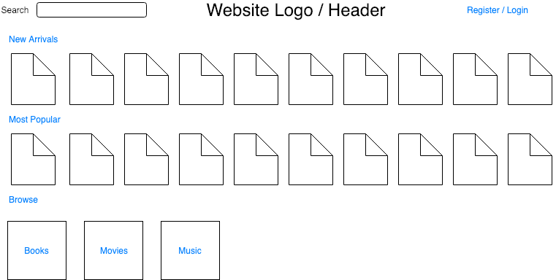

The main page has the following functionality:

* The ability to login or register for the site (link to other pages)
* A logo with the site’s name
* A simple text search box, the search text would be clickable to go to an advanced search page with the ability to search each individual field in the database.
  + Searching takes you to a search results page which lists any items that match your search
* The New Arrivals section lists the newest X (where X is configurable) items added to the library, showing the photo for the item and some way of knowing it is a movie, book, or music.
* The Most Popular section lists the X (where X is configurable) items that are the most popular at the library (as determined by number of borrows + number of holds).
* The Browse section has logos to take them to the browse page for books, movies or music.

# Main Page (Administrator Mode):

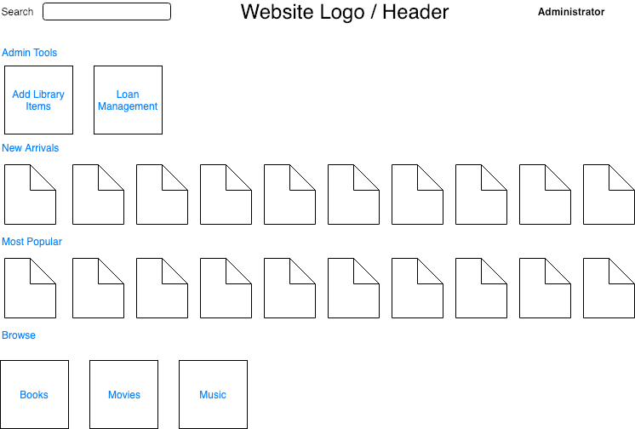

When in administrator mode the main page allows the administrator to:

* Do everything you can do in the normal main page
* A new section appears labeled “Admin Tools” with links to the Add Library Items page and the Loan Management page.

# Register / Signup Page:

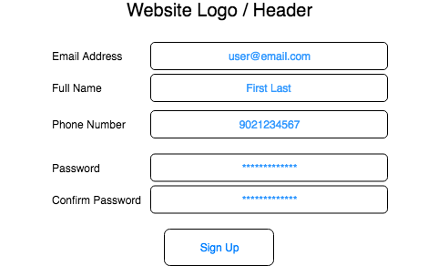

The registration page allows users to:

* Create new users in the system
* All of the fields in the page are required
* You must perform validation on the fields:
  + Emails cannot be empty strings, and must be unique in the database
  + Name cannot be empty strings
  + Phone numbers must be only digits
  + Passwords must meet some criteria (this is an excellent candidate for configurable business logic)
  + Passwords must match
* When users enter invalid data, they must be informed what’s wrong and how to fix it.
* When they successfully sign up, they should be redirected to the main page authenticated against their new user.

# Login Page:

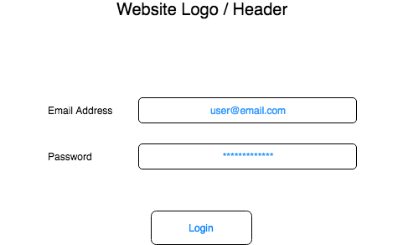

The login page must:

* Allow the user to login as a registered user via email and password OR as an administrator by entering “administrator” in the email address and the administrator password in the password box.
* The users email address and password are validated, if they match, they are logged into the system and redirected to the main page.
* Bonus points: Add the ability for users to retrieve or reset their passwords by clicking a “Forgot Password” link where they enter their email address and the system emails them a link to reset their password.

# Add Item Page

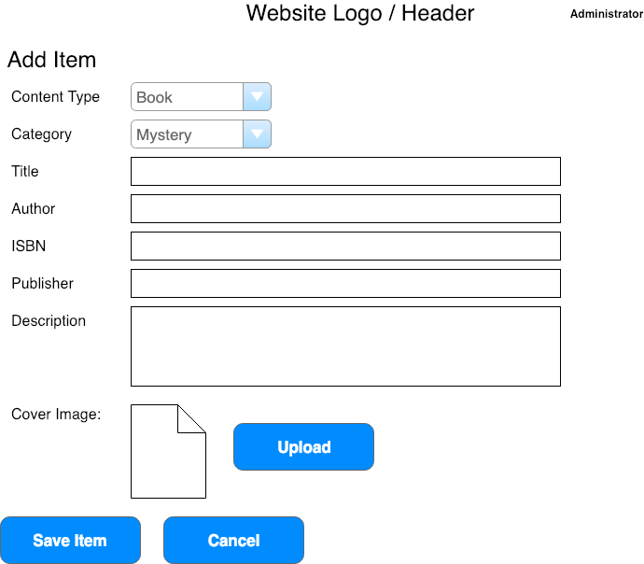

The add item page must:

* Change the context of what data is entered based on the dropdown. Each category has the following information:
  + Books:
    - Category (e.g. mystery, romance, history, science fiction, fantasy, etc…)
    - Title
    - Author
    - ISBN
    - Publisher
    - Full description / title details
    - A scan of the book’s cover
  + Music:
    - Category (e.g. rock, soul, blues, country, etc…)
    - Title
    - Artist
    - Record Label
    - Scan of the CD’s cover
  + Movie:
    - Category (e.g. action, thriller, comedy, drama, romance, etc..)
    - Title
    - Director
    - Description / title details
    - A scan of the DVD’s cover
* When the user clicks save all the data is saved in the database for a new entry in the library. The photo can be uploaded to a file structure on the server, or stored in the database.
* Cancel returns the user to the main page.
* The page must not allow the user to enter duplicate items in the database (items are considered duplicates depending on their context: a book is a duplicate if it has the same author and title, music is a duplicate if it has the same artist and title, a movie is a duplicate if it has the same director and title). Display a warning when a user tries to enter a duplicate item.

# Loan Management Page

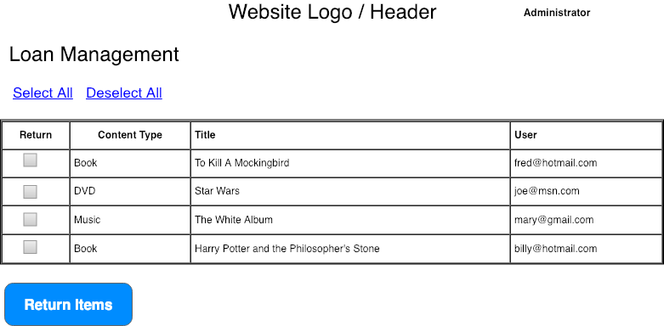

The Loan Management Page must:

* Display all outstanding borrowed items
* Allow the user to click the column header and sort by the column (title, content type, user)
* Check a box next to the item
* Select all items
* Deselect all items
* When the user clicks Return Items, all checked items are marked as returned to the library. This then triggers a process that looks for holds on the returned items. Items with holds notify the next user in line by email that the item is now available and automatically borrows the item for that user.

# Item Details Page

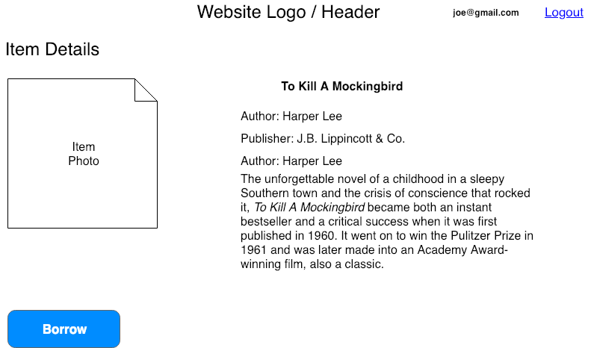

The Item Details Page must:

* Adapt to the context of the item to display the necessary information (e.g. for a book the title/author/publisher/details)
* Display the item’s image.
* Detect the status of the item in the database, if it is available to borrow the button at the bottom should say “Borrow” and allow the user to borrow the item. If the item is not available it should say “Place Hold” to place a hold on the item.

# Search Results Page

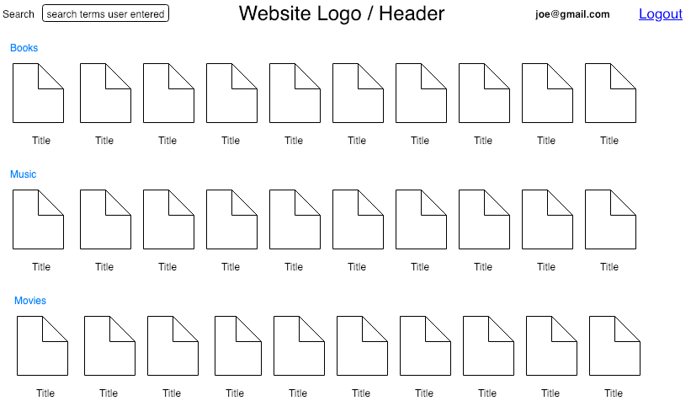

The search Results Page must:

* Display the results of the search, the item’s image, and the item’s title
* The results should be displayed in the context of the search. For example, if the user did an advanced search where they searched only books then the music and movies sections shouldn’t be displayed.
* Clicking any search result’s photo takes you to that item’s item details page.
* The search box should be prepopulated with the terms they used to search.

# Advanced Search Page

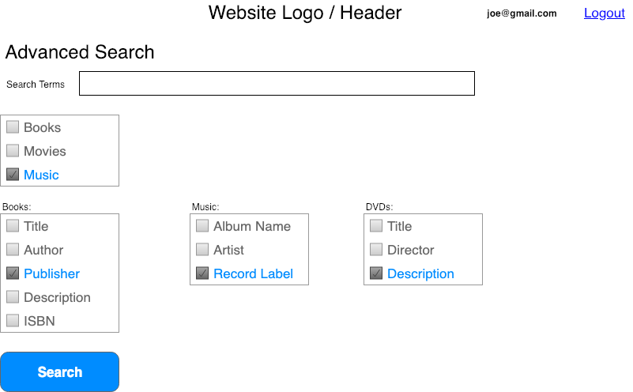

The Advanced Search Page must:

* Allow the user to search by a limited selection of content type, or fields that apply to the selected content type(s).
* When the user selects a content type, the bottom group of checkboxes that apply to that content type become active and the user can then select which fields of that content type to search. When the content type is not selected, the field box for that content type is disabled and all fields in the box are unchecked.
* Searches executed from this page search ONLY the content types and fields selected by the user.
* Search results are displayed on the search results page as usual.

# Browse Page

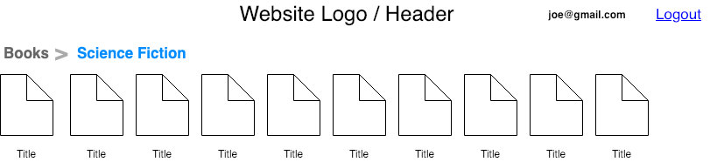

The Browse Page must:

* When the user selects “Books”, “Music”, “Movies” from the main page, they should land on the starting point of the browse page. This lists all of the categories under the content type (e.g. for books: science fiction, romance, non-fiction, etc..)
* Choosing one of the categories takes you to a browse page and a breadcrumb is displayed in the top left to show the user what category they are browsing.
* All items matching the content type and category the user selected are then displayed.
* Clicking any item takes you to that item’s item detail page.